PATIENT REGISTRATION INITIAL APPOINTMENT DATE_______ / ______/ ________

NAME_____________________________________________________________________ DATE OF BIRTH_______ /______/_________

ADDRESS ________________________________________________________________________________________________________

HOME PHONE _____________________________________ CELL PHONE ___________________________________________________

EMAIL ADDRESS _________________________________________________________________________________________________

PRIMARY INS. ____________________________________________________________________ ____________________________
Name Member ID / Group Numbers

SUBSCRIBER NAME ______________________________________ DOB____/ _____/ ______RELATION________________________

ADDRESS______________________________________________________________________________PHONE ____________________
If different from above
SECONDARY INS. _________________________________________________________________ ______________________________
Name Member ID / Group Numbers

SUBSCRIBER NAME ______________________________________ DOB____/ ____/ _______RELATION___________________________

ADDRESS______________________________________________________________________________PHONE ___________________ If different from above

I realize that my insurance coverage is a contract between myself and the insurance company and that not all services may be covered benefits in all health plans. By signing this agreement, I am acknowledging that I am ultimately responsible for any unpaid balance on my account for services rendered. I hereby assign to Arthritis Health Associates, LLC, the medical benefits to which my dependents and/or I am entitled. I authorize the release of any medical or other information necessary to process this claim and/or to collect this debt. I hereby agree to pay my personal balance within 30 days of receiving a statement. Moreover, a finance charge at the rate of 1 ½ % per month will be added to all unpaid balances more than 60 days past due. In addition, I agree to pay any additional charges to collect my unpaid bills, including but not limited to, reasonable attorney fees, court costs and collection agency fees. I agree to pay a $25 service charge on all returned checks. I am aware that my account will be charged $50 for any appointments I fail to make without calling within 24 hours notice. By signing below, I do affirm that I have read all the above information and have answered all questions truly and to the best of my ability. I also affirm that I understand the contents of this document.
I am aware that AHA’s HIPAA policy is posted in the office and can be viewed by me at anytime.

SIGNATURE_____________________________________________________________________________DATE____/______/ _________
Patient

SIGNATURE_____________________________________________________________________________DATE____/ _____/ _________
Parent / Guardian / Power of Attorney

Patient Name |  | Appointment Date
Patient Date of Birth |  | Gender
Medications
Please list below all drugs and medications taken over the last week
(include birth control pills, aspirin and any kinds of over the counter drug or medication of any kind)

Name of Drug or Medicine | Dosage If Known | How Many Per Day | How Helpful is it?  (a lot) (some) (none) | Any Side Effects?  (yes) (no) | If Yes what is it?  (GI) (Skin) (Other)
⃞ Please check box if you are not taking any prescribed or over the counter medications at this time.
Pharmacy Information
Pharmacy Name |  | Phone # |  | Address
Pharmacy Name |  | Phone # |  | Address

Signature: Date:

HIPAA POLICY
As required by the Privacy Regulations created as a result of the Health Insurance Portability and Accountability Act of 1996 (HIPAA) we are committed to maintaining the privacy of your personal health information (PHI).
Your PHI will be used in the normal course of business for treatment and to bill you and/or your insurance company for payment of our services. Please assist us in clarifying with whom and how we may communicate information concerning your care.
PRINT PATIENT NAME: ___________________________________________________________ DOB: ____________________

Email: _ _________________________________________________________________________________________________

Home phone #:_____________________________________ Cell Phone #:___________________________________________

PREFFERED Method of contact (choose one): Text Message Home Call Cell Call
AHA may remind me about a FUTURE OFFICE APPOINTMENT
Check all that apply…. HOME/CELL VOICEMAIL: YES NO
WITH ANOTHER PERSON (please list names & contact information below): YES NO
LETTER: YES NO
AHA may communicate my PERSONAL MEDICAL INFORMATION (lab results, treatment plans, etc):
Check all that apply…. HOME/CELL VOICEMAIL: YES NO
WORK VOICEMAIL: YES NO
WITH ANOTHER PERSON (please list names & contact information below): YES NO
LETTER: YES NO
AHA may contact my pharmacy and obtain my past medication history.
I prefer to not release my past medication history.
Patient Portal Care Manager (indicate below):
(another individual you give permission to access your Patient Portal Account):

Name:_______________________________________________________Email_______________________________________
My PERSONAL MEDICAL INFORMATION may be discussed with the following relatives, friends, healthcare proxies, caregivers, etc. (please do not list referring physicians):
CONTACT NAME | RELATIONSHIP | PHONE # | CELL PHONE #
Please list here any additional instructions you may have regarding how Arthritis Health Associates handles your PERSONAL MEDICAL INFORMATION:
Updated 4/21/23

Signature: _____________ Date:

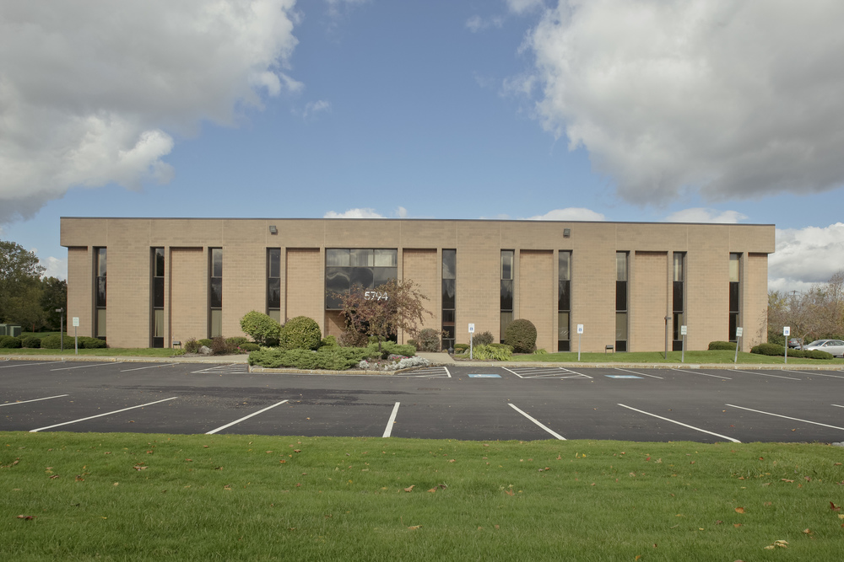

From the North
Take I-81 South toward Syracuse
Take exit #29S onto I-481 South toward Dewitt
Take exit #4 onto I-690 West toward Syracuse
Take exit #17/Bridge Street
Turn right on Bridge Street
Turn left on Widewaters Parkway

From the South
Take I-81 North
Take exit #16A onto I-481 North toward Dewitt
Take exit #3W and merge onto Rt. 5 West/Rt. 92 West/East Genesee toward Dewitt
Turn right to follow Rt. 5 West/Erie Blvd. East
Turn right on Kinne Road
Turn left on Widewaters Parkway

From the West
Take the I-90 East

Take exit #39 onto I-690 East toward Syracuse
Take exit #16-17/Rt. 635
Turn right onto Bridge Street
Turn left on Widewaters Parkway

From the East
Take I-90 West toward Buffalo
Take exit #34A onto I-481 South toward Syracuse
Take exit #4 onto I-690 West toward Syracuse
Take exit #17/Bridge Street , turn right on Bridge Street
Turn left on Widewaters Parkway

Arthritis Health Associates PLLC
Authorization for Access to Patient Information
New York State Department of Health Through a Health Information Exchange Organization

Patient Name | Date of Birth
Other Names Used (e.g., Maiden Name):

I request that health information regarding my care and treatment be accessed as set forth on this form. I can choose whether or not to allow Arthritis Health Associates to obtain access to my medical records through the health information exchange organization called Health_{e}Connections. If I give consent, my medical records from different places where I get health care can be accessed using a statewide computer network. Health_{e}Connections is a not-for-profit organization that shares information about people’s health electronically and meets the privacy and security standards of HIPAA and New York State Law. To learn more visit Health_{e}Connections website at http://healtheconnections.org/ .

My information may be accessed in the event of an emergency, unless I complete this form and check box #3, which states that I deny consent even in a medical emergency.

The choice I make in this form will NOT affect my ability to get medical care. The choice I make in this form does NOT allow health insurers to have access to my information for the purpose of deciding whether to provide me with health insurance coverage or pay my medical bills.

My Consent Choice. ONE box is checked to the left of my choice.
I can fill out this form now or in the future.
I can also change my decision at any time by completing a new form.
  - 1. I GIVE CONSENT for ARTHRITIS HEALTH ASSOCIATES to access ALL of my electronic health information through Health_{e}Connections to provide health care services (including emergency care).
  - 2. I DENY CONSENT for ARTHRITIS HEALTH ASSOCIATES to access my electronic health information through Health_{e}Connections for any purpose, even in a medical emergency.

If I want to deny consent for all Provider Organizations and Health Plans participating in Health_{e}Connections to access my electronic health information through Health_{e}Connections, I may do so by visiting Health_{e}Connections website at http://healtheconnections.org/ or calling Health_{e}Connections at 315.671.2241 x5.

My questions about this form have been answered and I have been provided a copy of this form.

Signature of Patient or Patient’s Legal Representative | Date
Print Name of Legal Representative (if applicable) | Relationship of Legal Representative to Patient (if applicable)

